Problem 8:

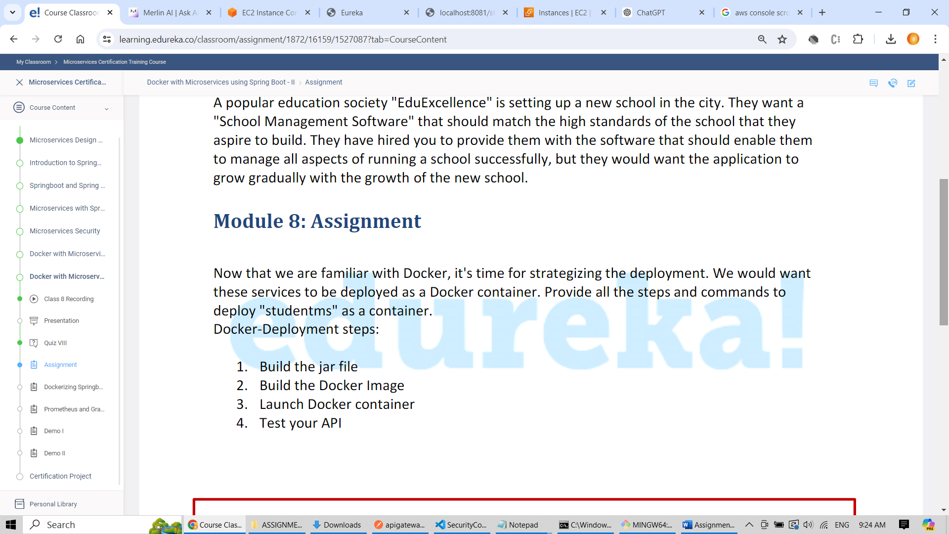

1. Build studentms.jar

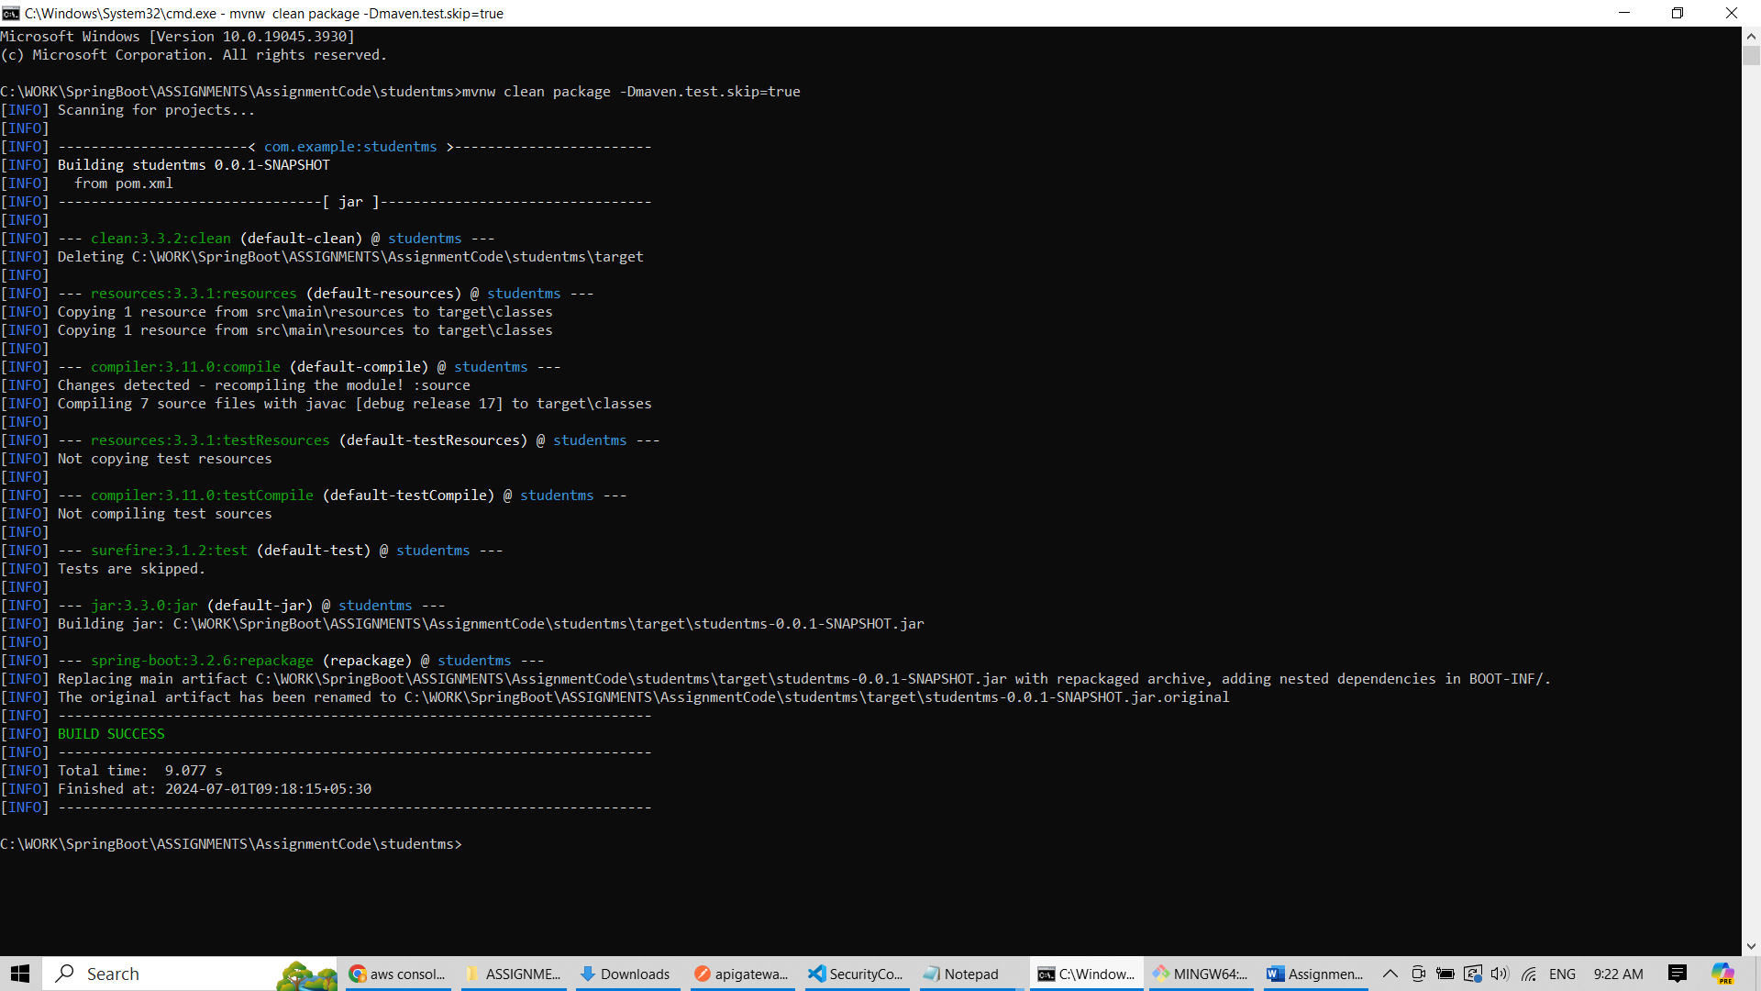

1. Placed private key pem file in the same directory of jar for ease of use

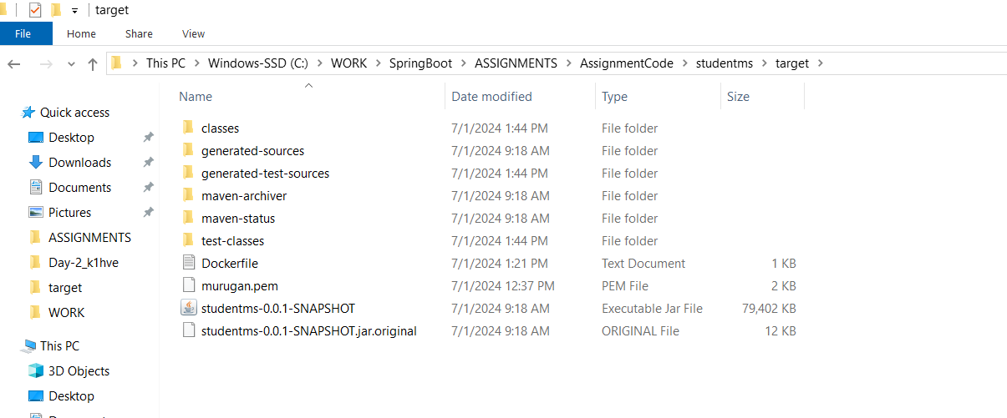

1. Run following commands in order

* Sudo su – login as a super user
* ”apt update” - to update the os
* “apt install docker.io” – to install the docker

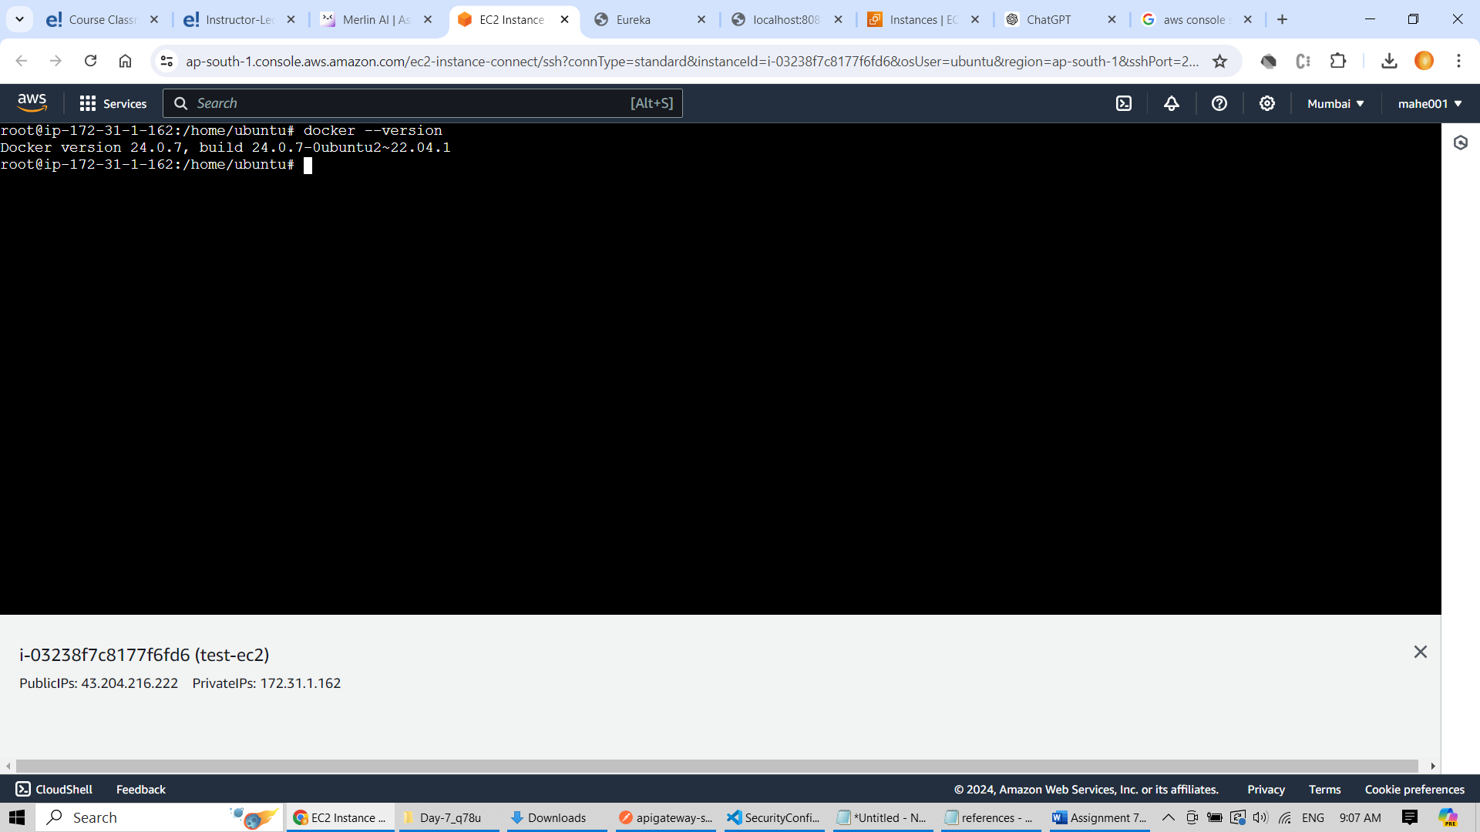

1. Copy the studentms.jar from windows to EC2 ubuntu using the following command

scp -i "murugan.pem" -r studentms-0.0.1-SNAPSHOT.jar ubuntu@ec2-3-110-122-227.ap-south-1.compute.amazonaws.com:/home/ubuntu



1. Update the security group inbound rules setting so that traffic from browser can hit this EC2 instance.

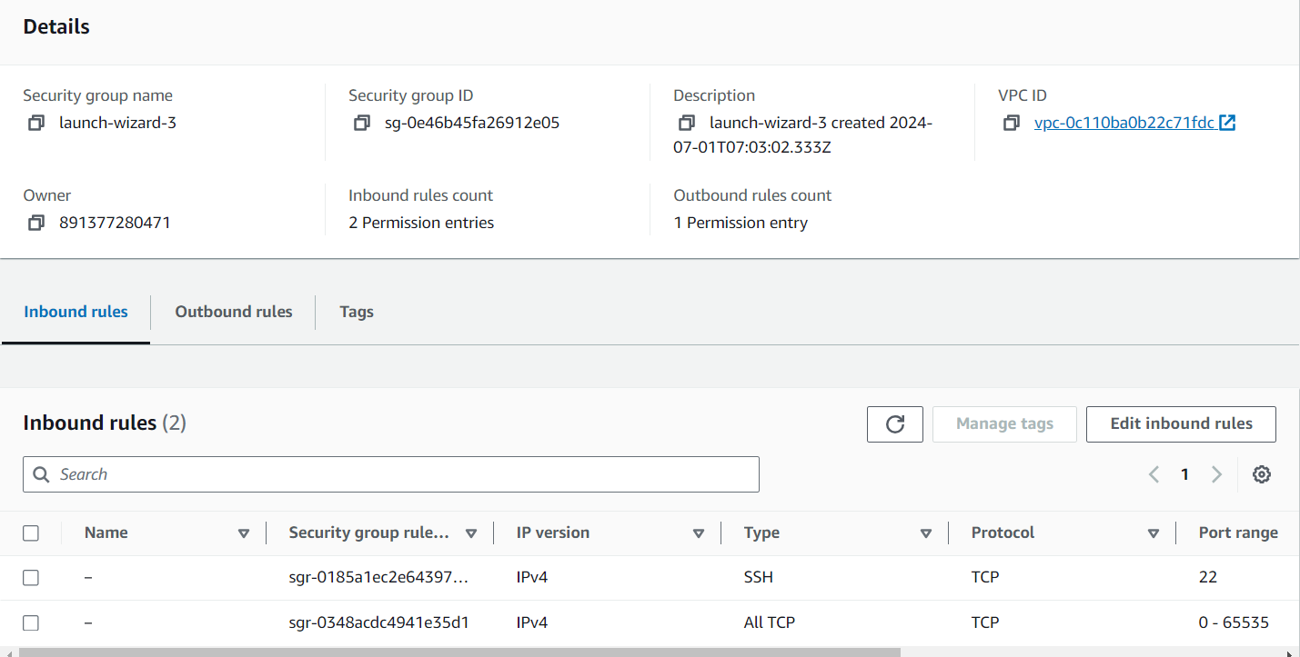

1. Created docker file using vim editor and placed the following content

FROM openjdk:17-jdk-slim

COPY studentms-0.0.1-SNAPSHOT.jar studentms.jar

ENTRYPOINT ["java","-jar","/studentms.jar"]

1. Run following command in the order in order to deploy studentms using docker container.

docker image build --tag studentms:1.0 .

docker run -d -p 8081:8081 -t studentms:1.0

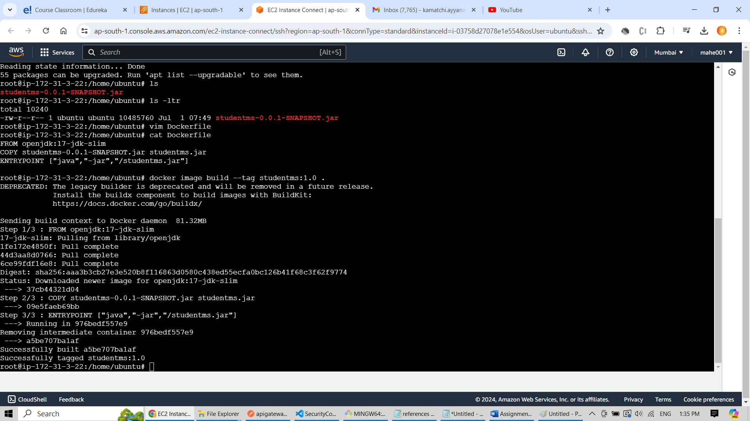

1. Test the deployment from aws console

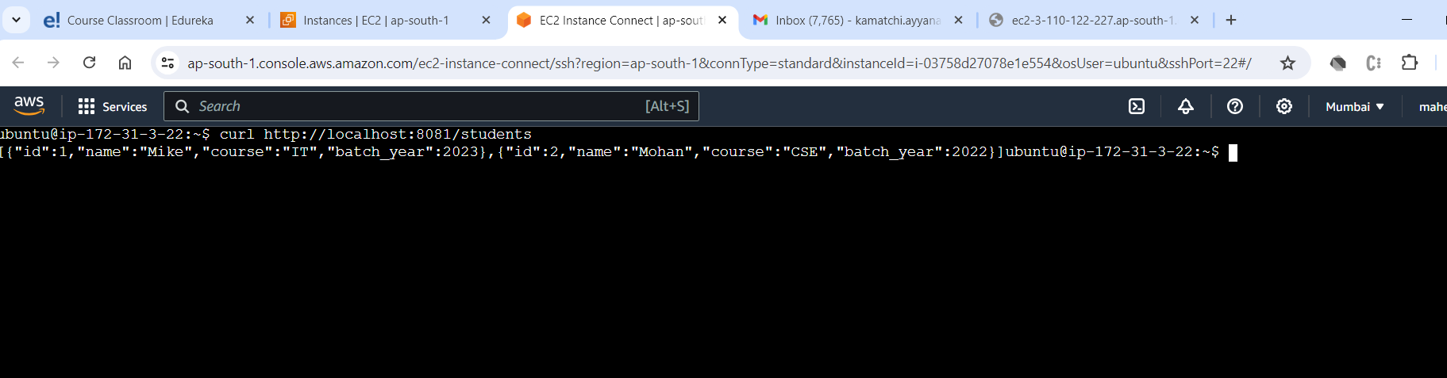

1. Could able to hit the running studentms from chrome browser.

